**LOGISTIC APP DOCUMENT**

**CLIENT USER**

1. **Client Dashboard**

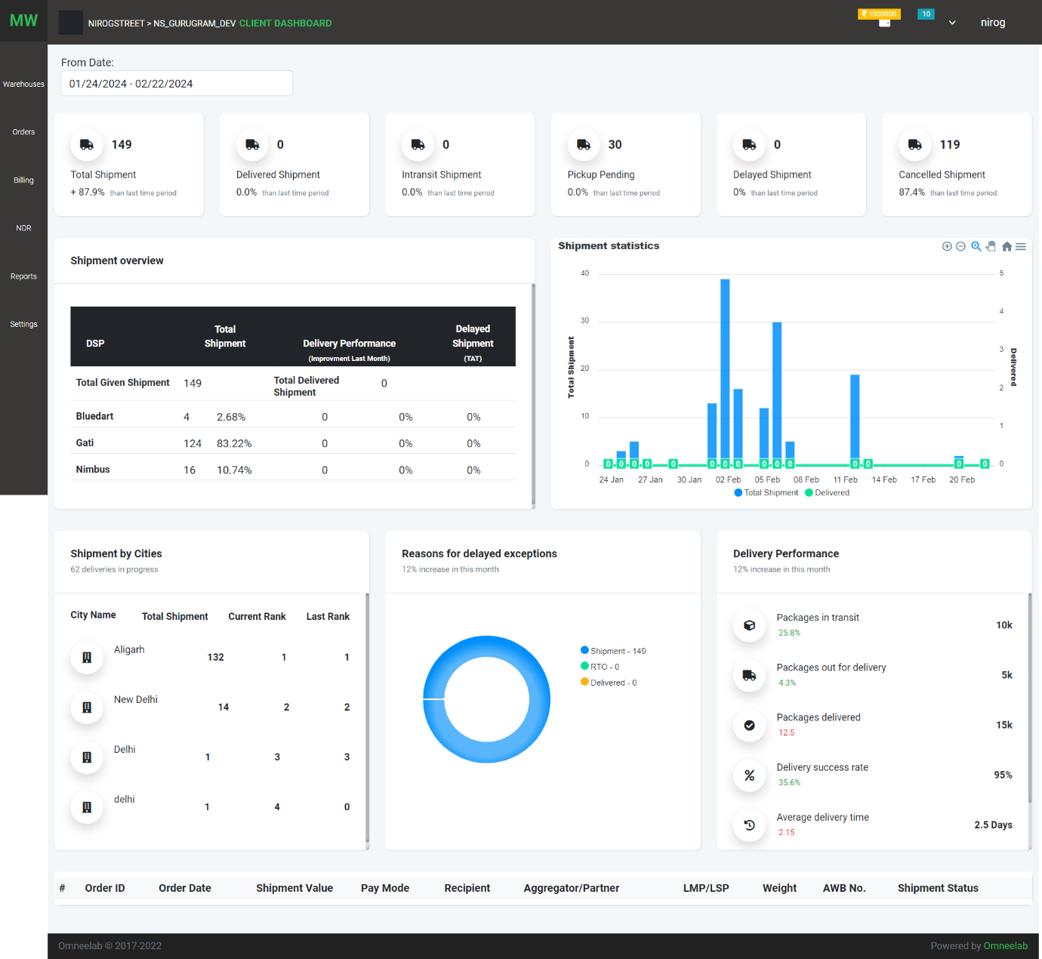

In this dashboard, we have details of all the warehouses of a client.

All data shown on a particular date interval

1. Total Shipment
2. Total Delivered Shipment
3. Total In transit Shipment
4. Total Pickup Pending
5. Cancelled Shipment
6. Shipment Overview:
7. Total no of given shipment,
8. total and per cent given shipment to DSP,
9. total and per cent delivered shipment of given shipment to DSP
10. delayed shipment and tat
11. Shipment Statics: Total shipment Vs. delivered shipment combo chart
12. Shipments by Cities:
    1. Cities that get the maximum no of order
    2. View progress by giving rank to cities and check what previous range on the same date interval
13. Reason Delayed Shipment
    1. Doughnut chart for checking the performance of order arrival on the expected date
    2. Chart colour changes when the delay order is less or more than the order on the expected date
14. Delivery Performance
15. Table shows: out of delivery order list
16. **User Profile:**
17. Use can update profile

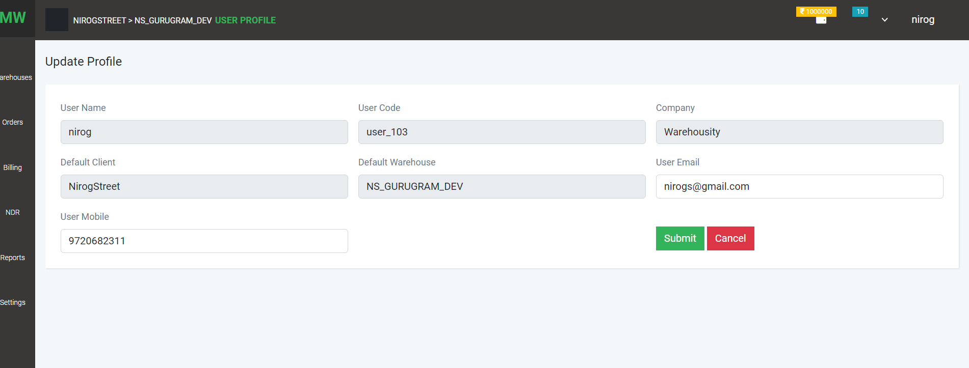

1. 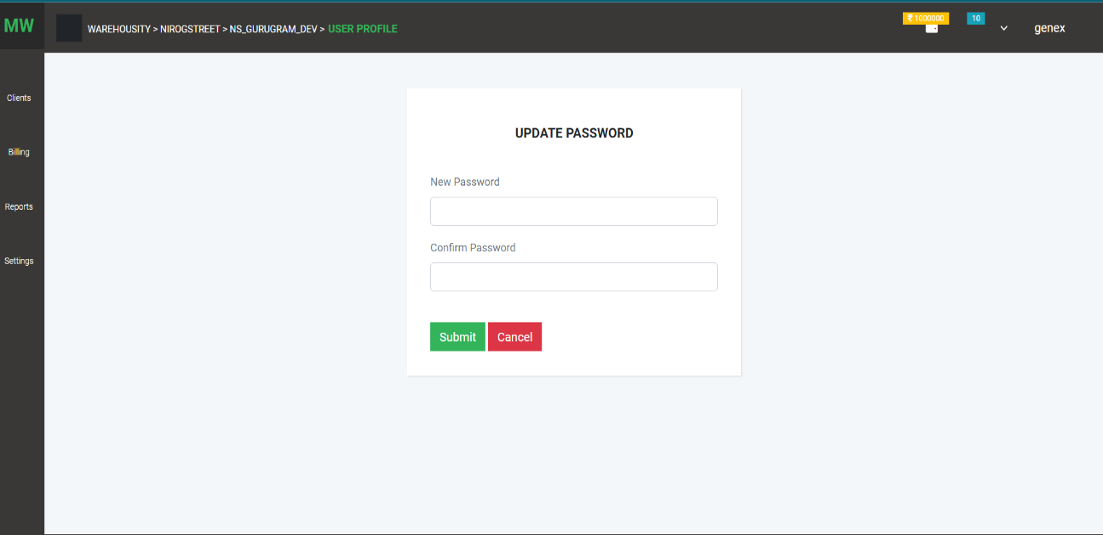Change Password:
2. Client profile

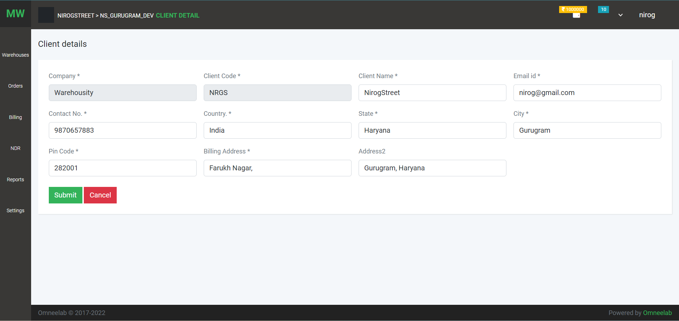

**WAREHOUSE LIST**

On this page, users can see a list of warehouses

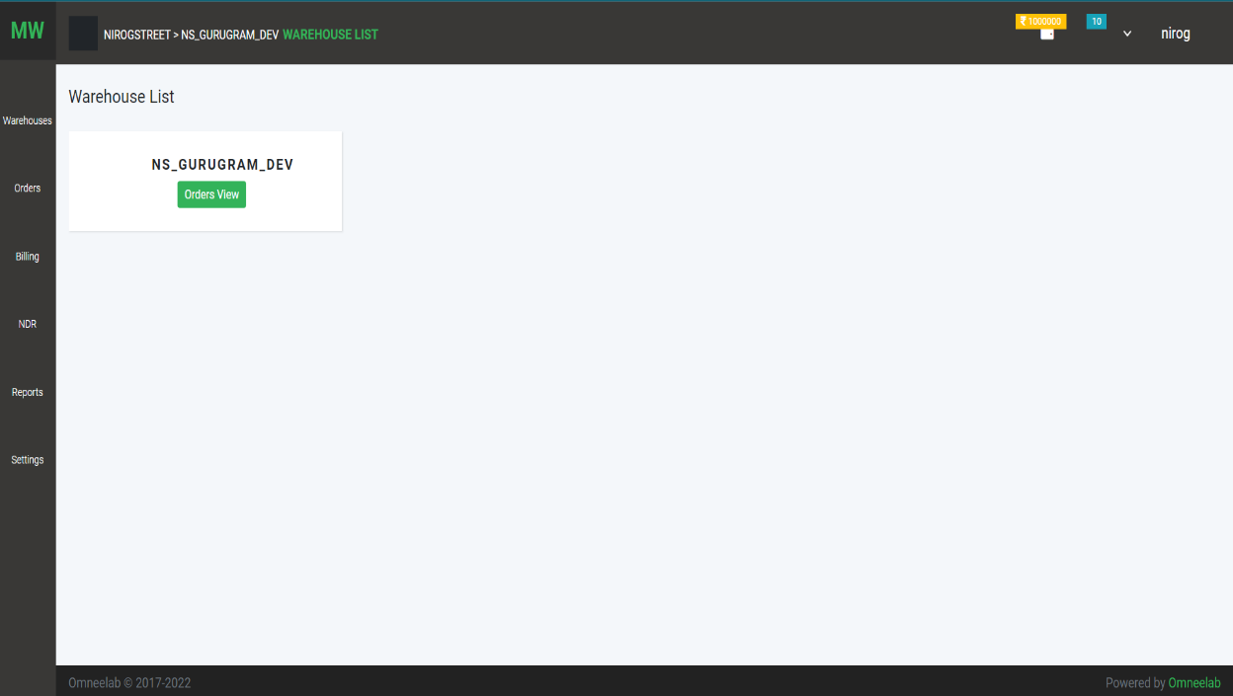

On this page, users can see a list of warehouses

1. Click on the warehouse name, user can see the warehouse detail
2. Click on the order list we can see the order list of that warehouse.
3. 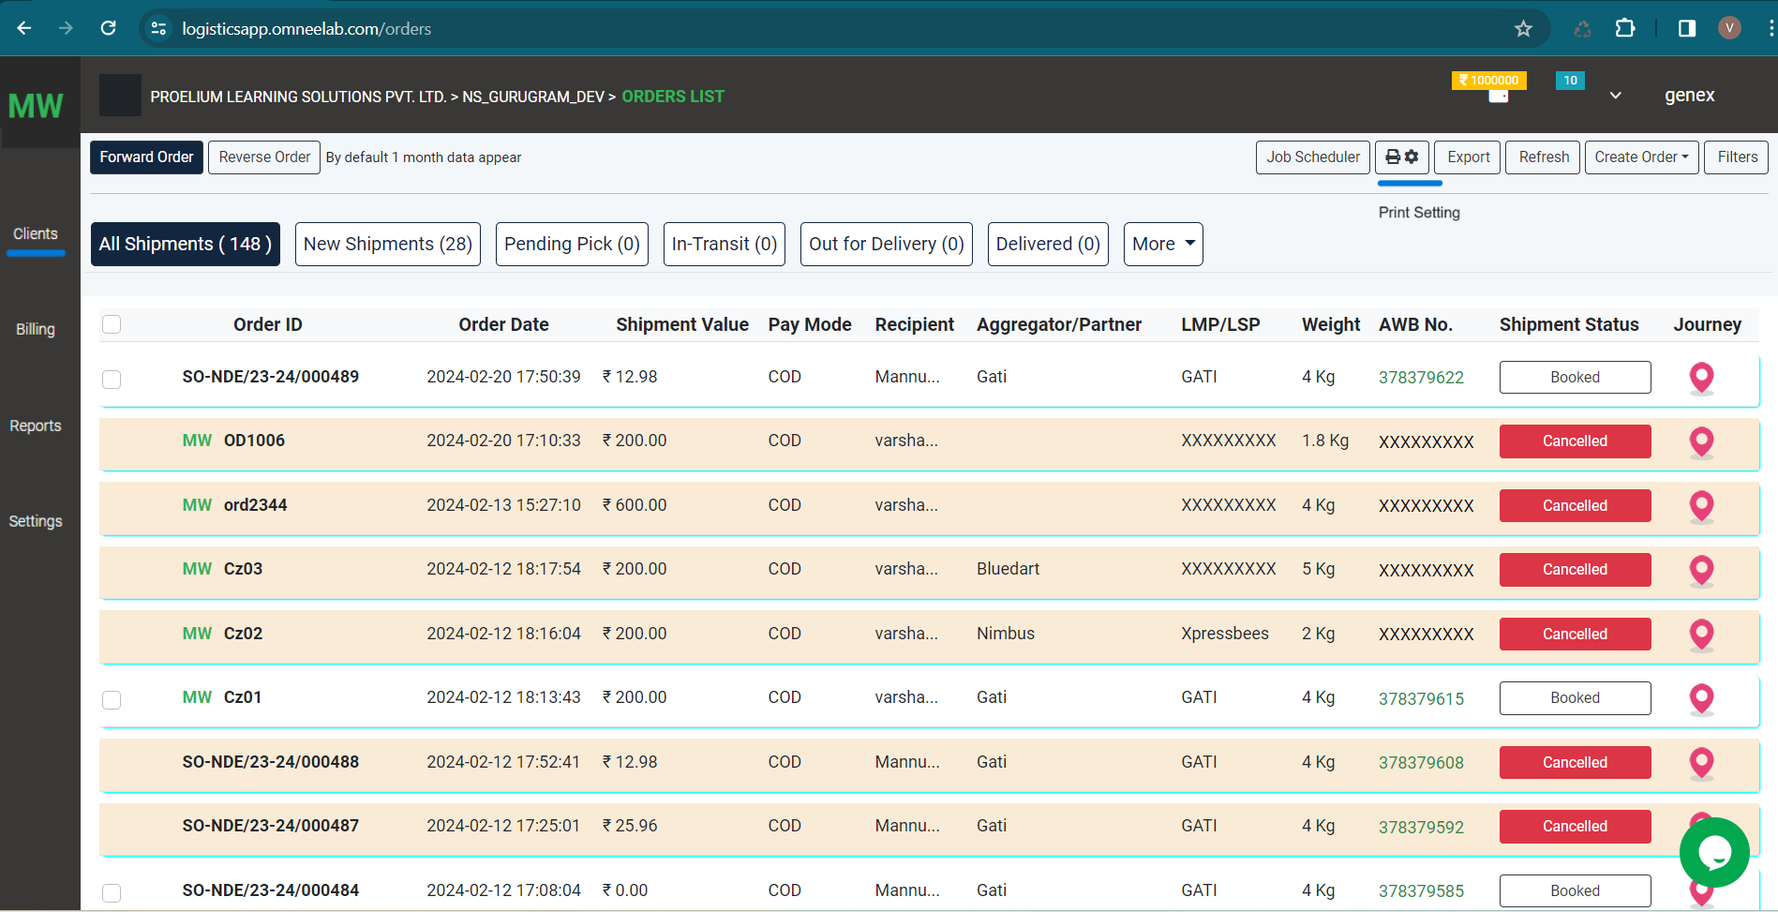**Orders**

On this page, the user can see a list of Orders

1. Two types of orders Forward Order and Reverse Order
2. Job Scheduler – New orders will be cancelled when no activity is performed within two hours
3. Print Setting - user can set a label print setting that will apply to the label
4. DSP Selection on booked status on manual order

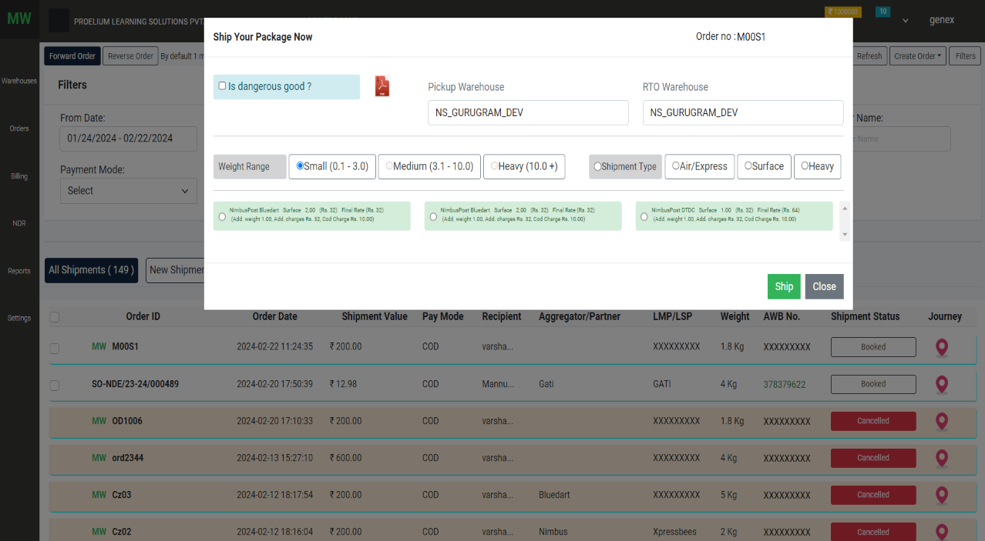

1. Tracking: The user can track order detail

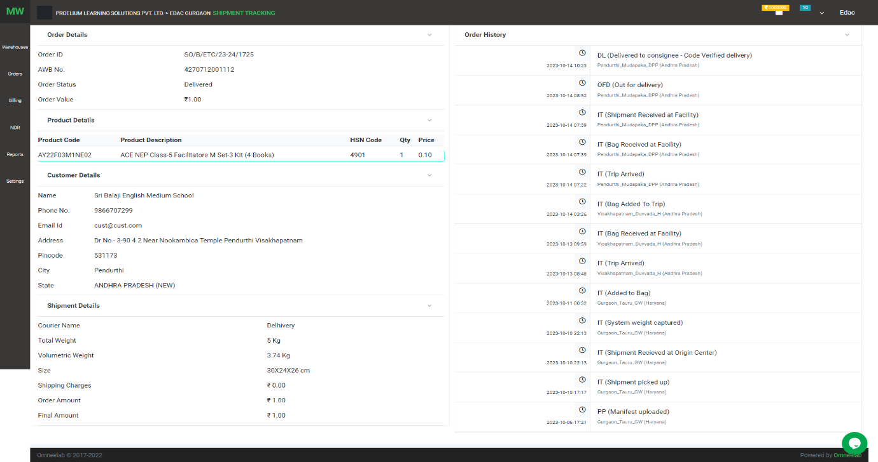

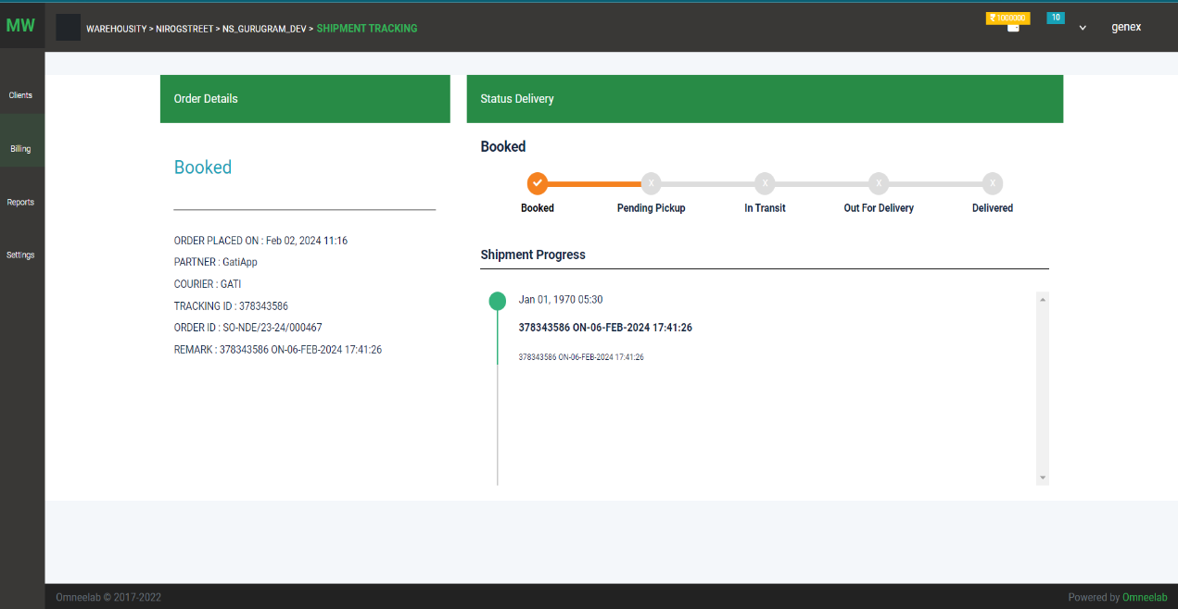Click on AWB no tracking page

1. Create order - manual order creation

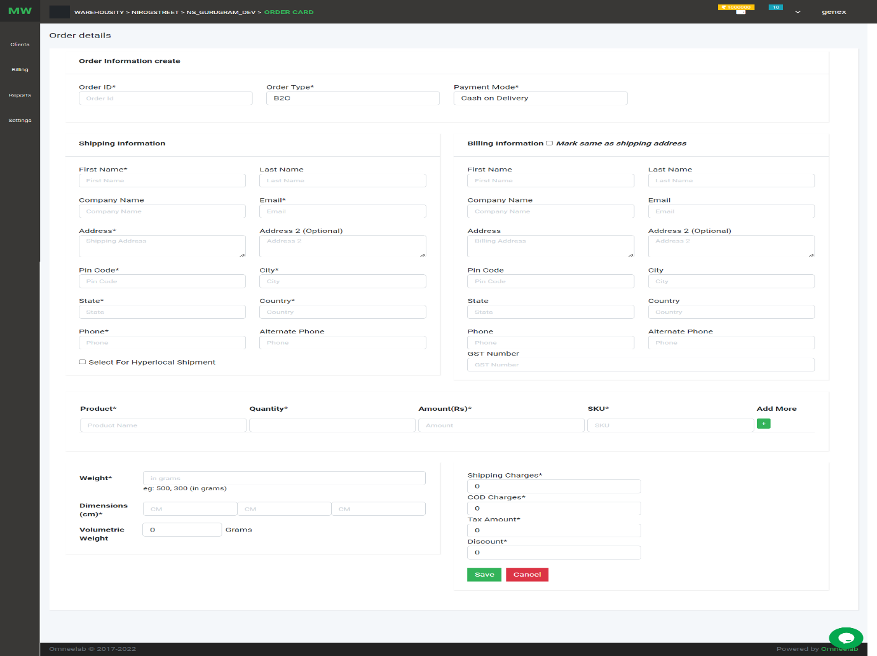

1. 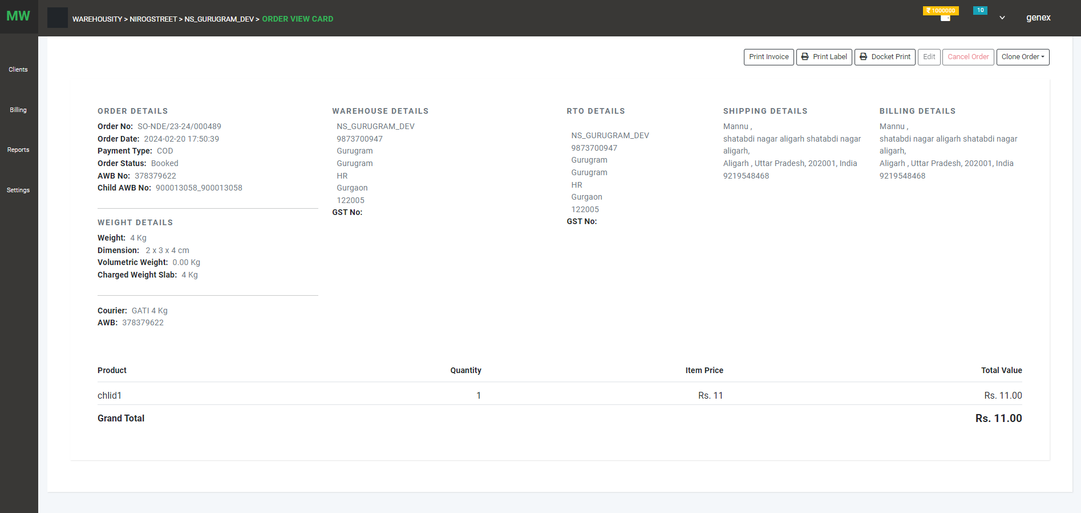Order detail view page

Option shown on this page:

1. 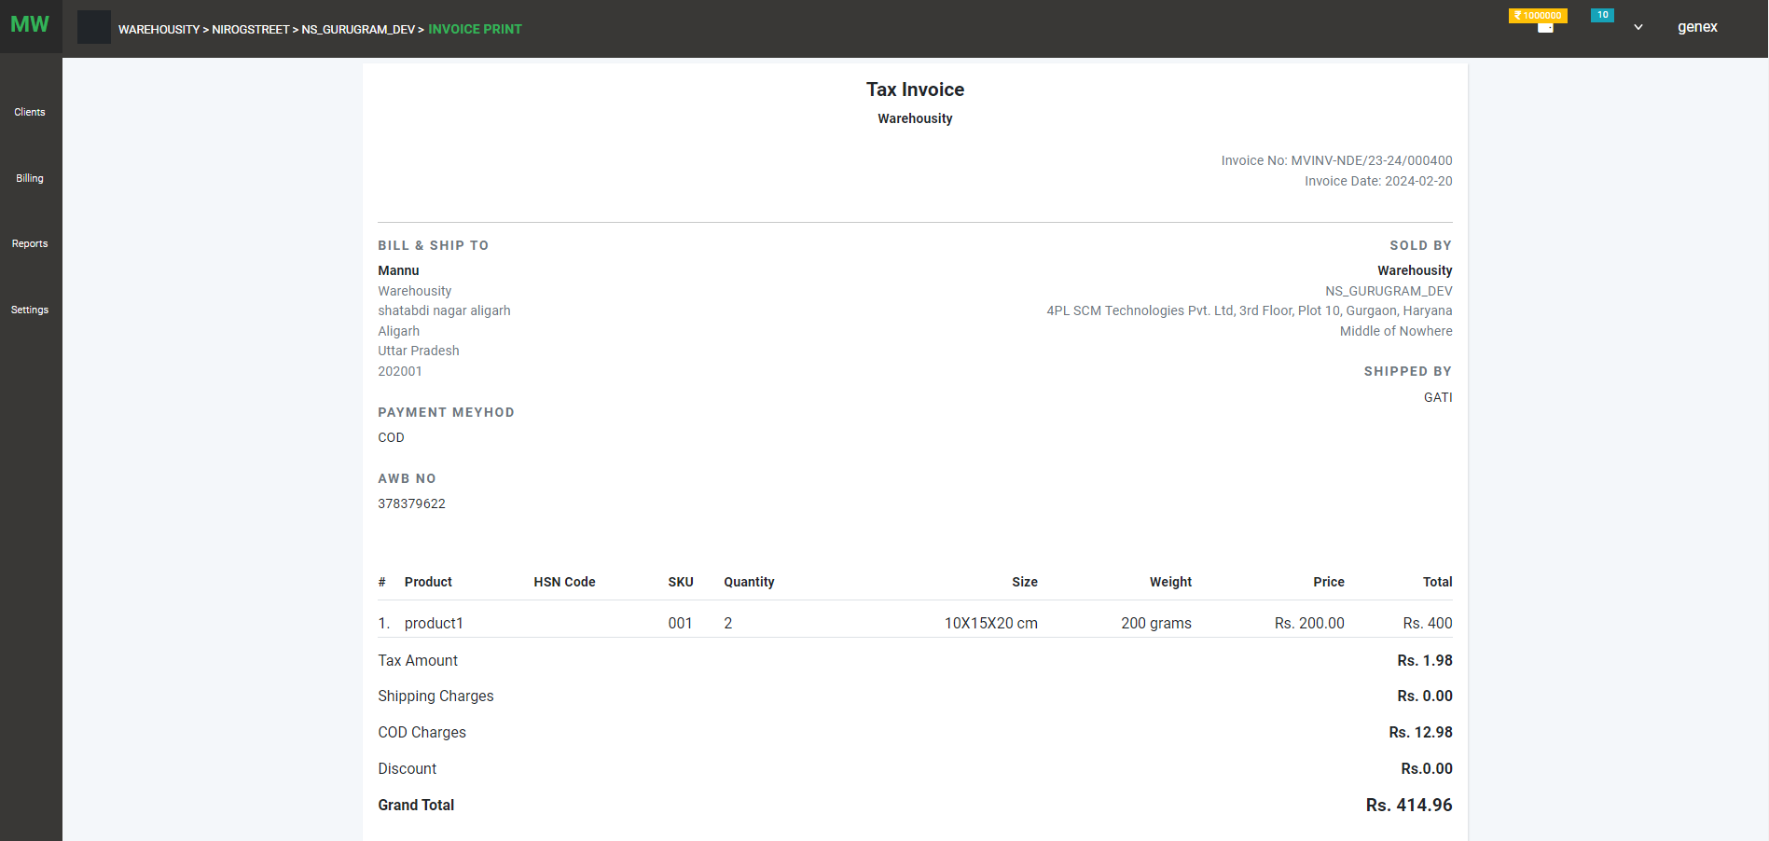Print invoice: order invoice includes order detail, consignee detail, product detail
2. Print label: download packing and ship against order
3. Docket Print: download docket details like AWB no against the order
4. Edit Order: user can edit the order before ship status on the manual order
5. Cancel order: user can cancel order before the pending pick status
6. Clone Order: user can repeat order using clone option
7. **SETTING:**

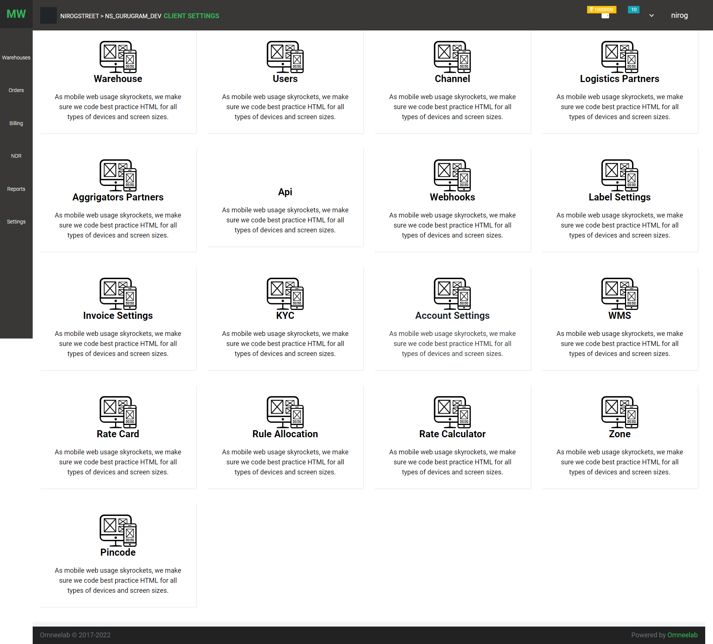

1. Warehouse: This option has a warehouse list and creates the option

List page

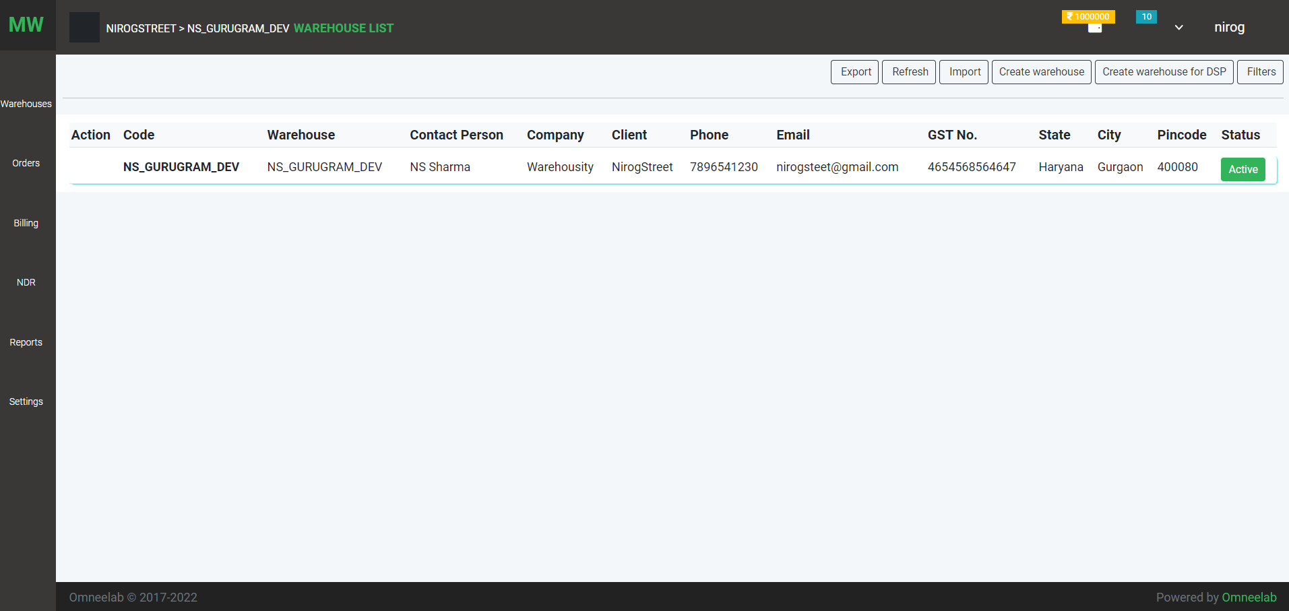

Create page

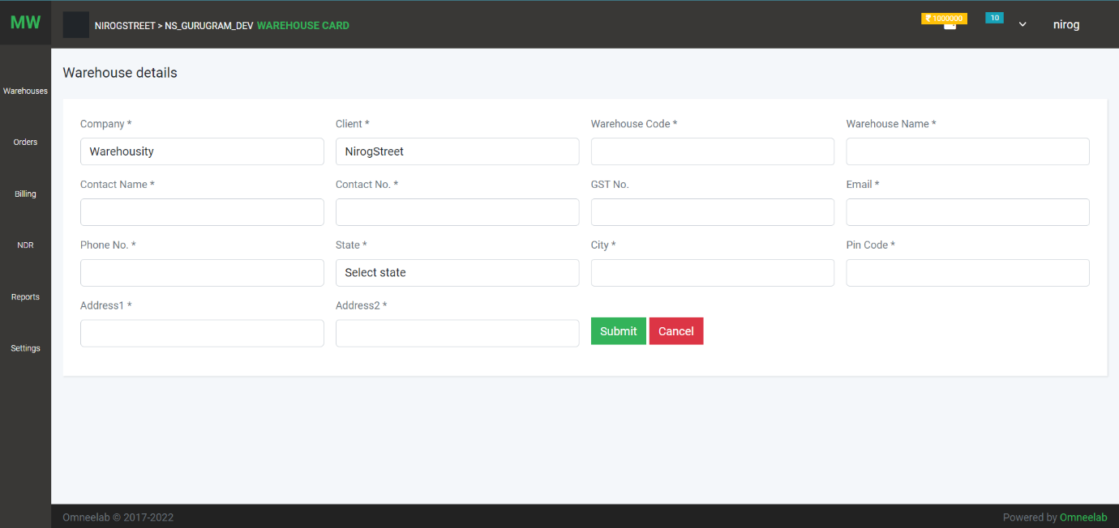

1. User: This option has a user list and creation

List page

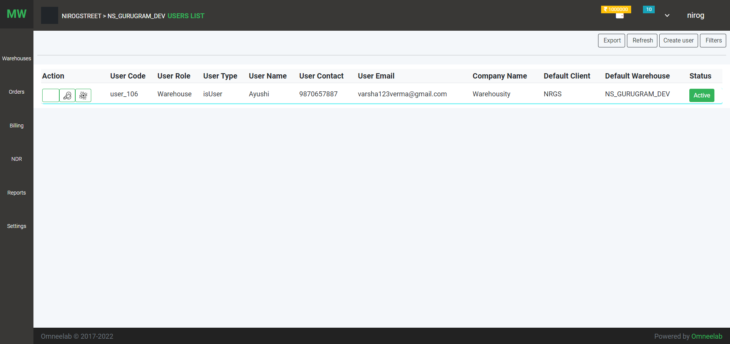

Creation page

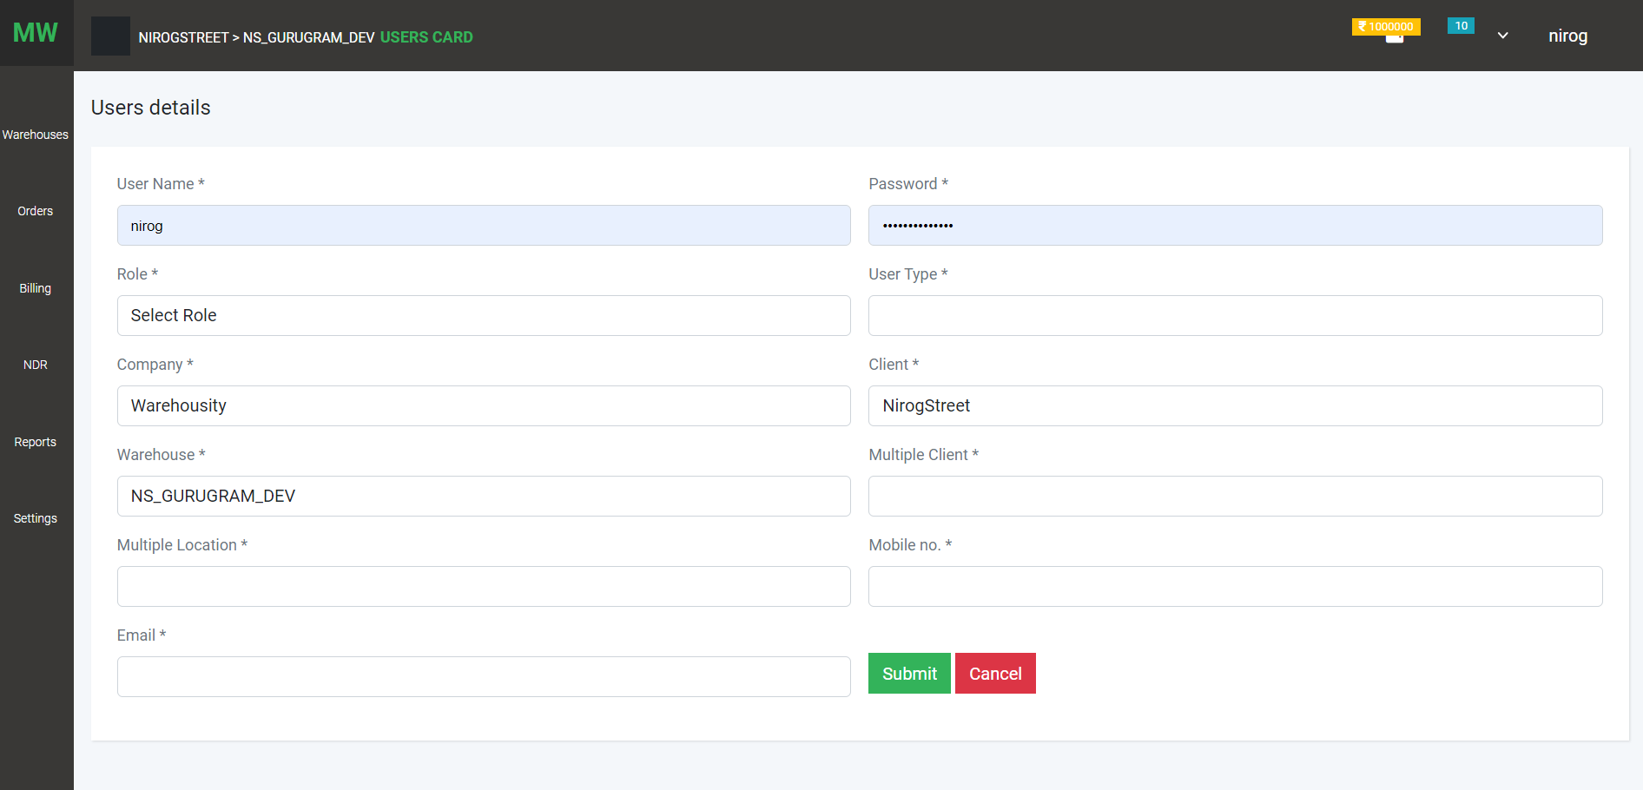

1. Channel partner: channel partner list

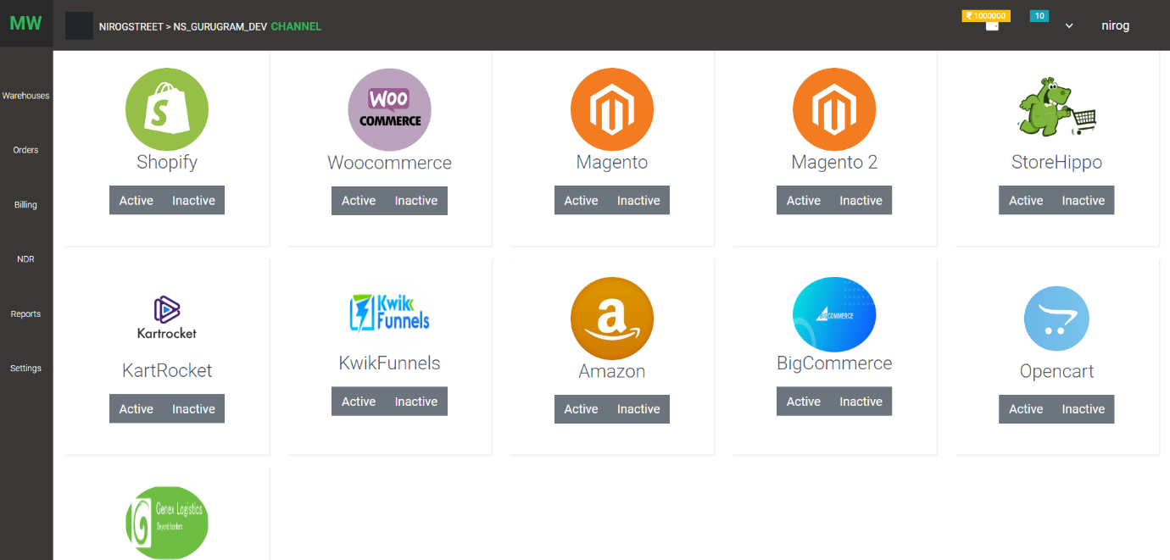

1. Logistics Partner: list of logistics partner

List page

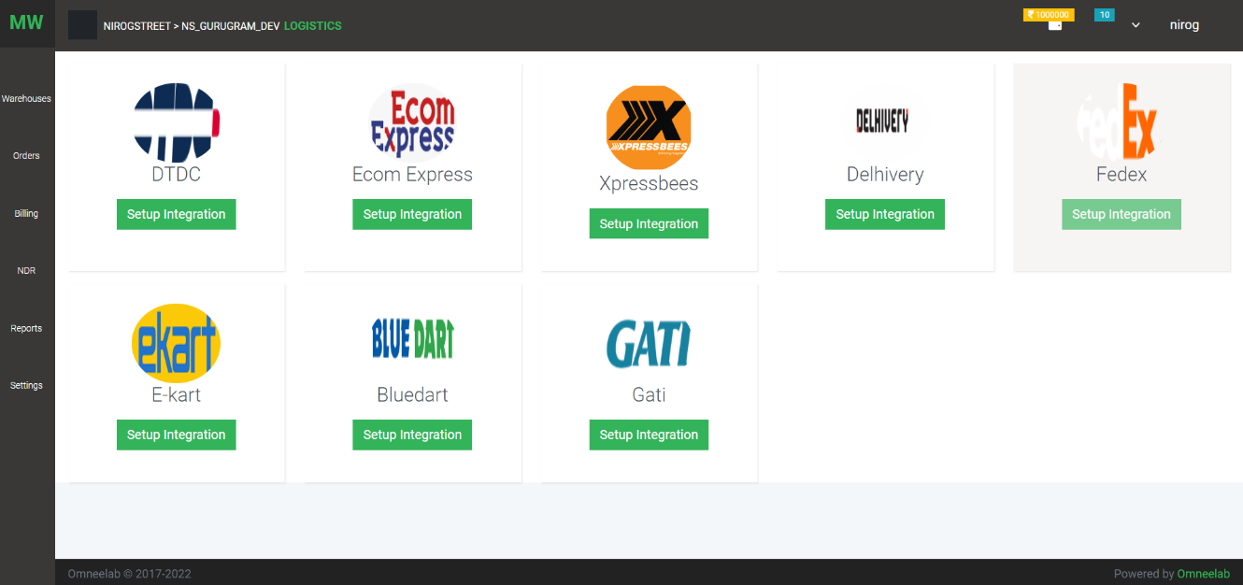

Configuration setup

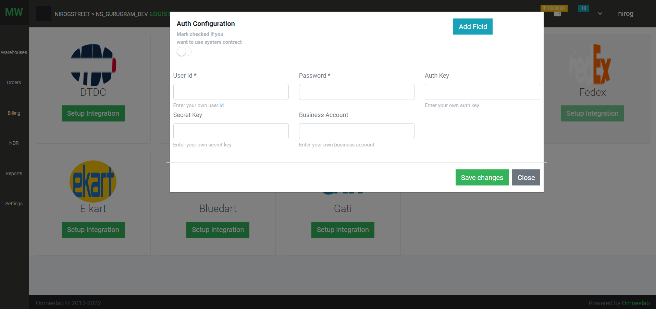

Custom field on the configuration screen

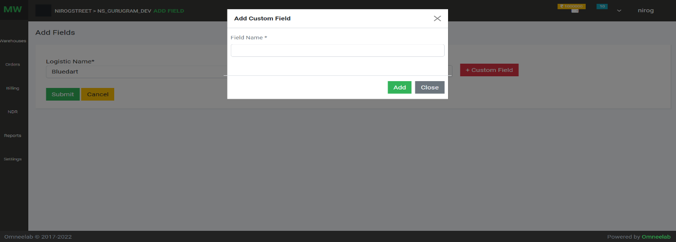

1. Aggregator: list of aggregators

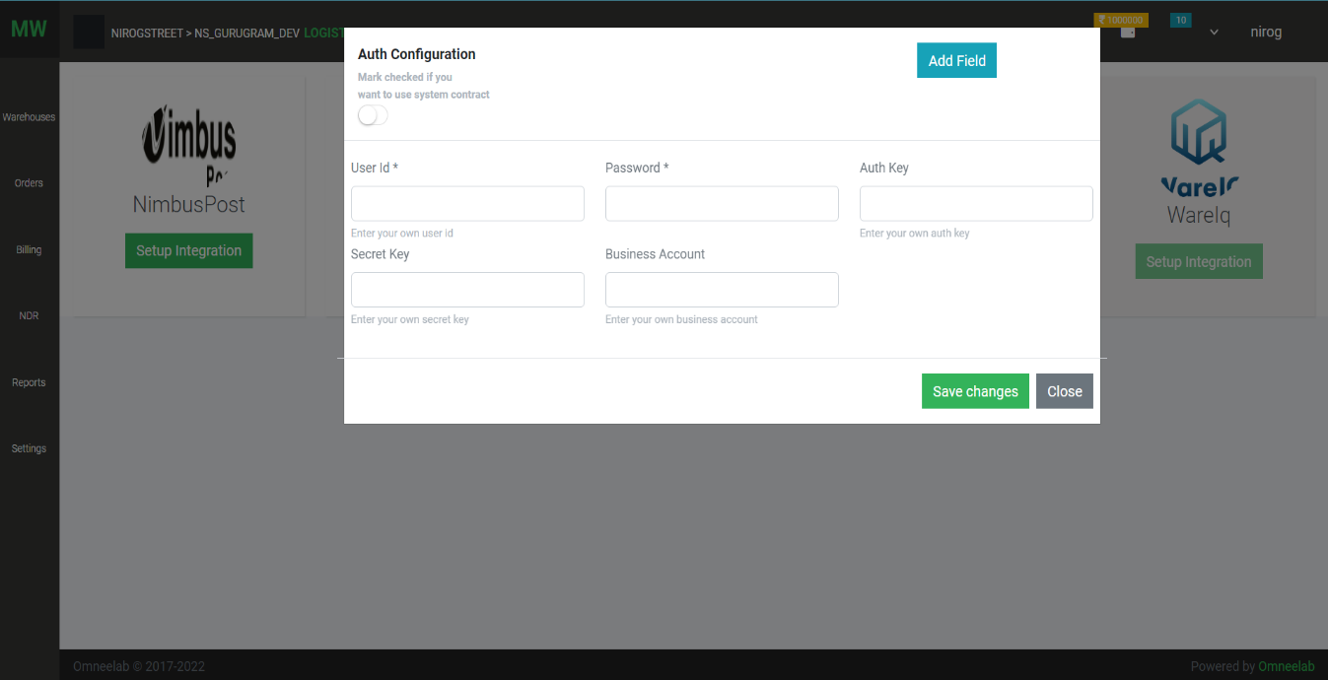List page & Configuration setup screen

1. 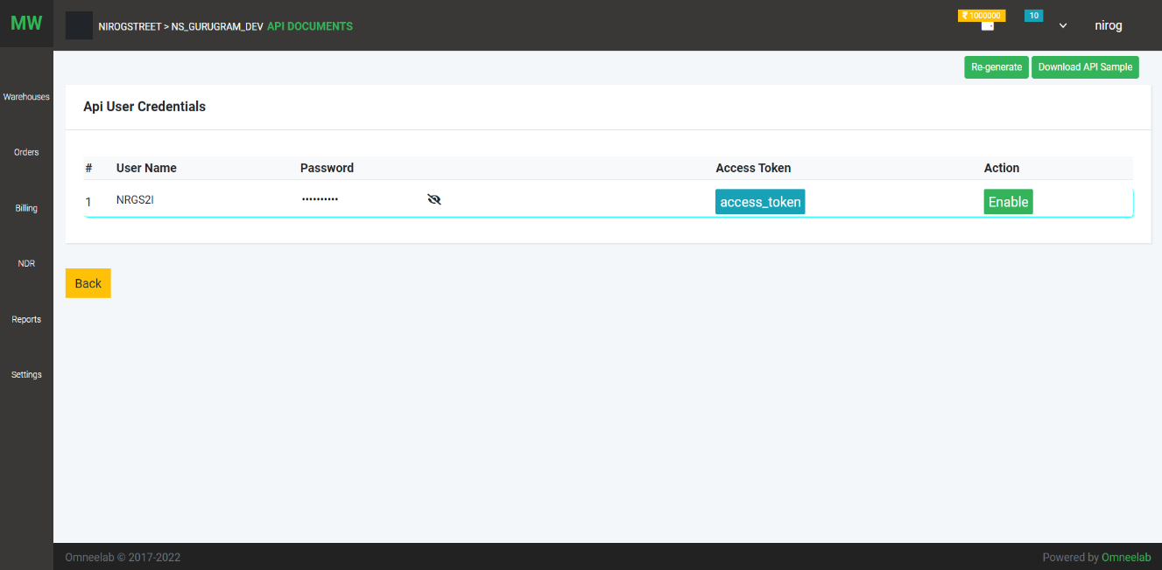API: API Document and API user creation and token generation
2. Webhook: get real-time order status

List

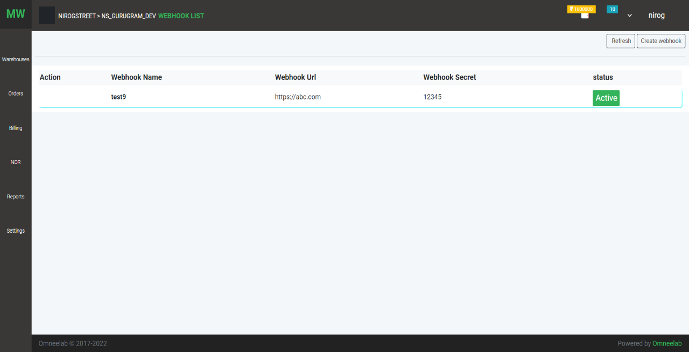

Creation page

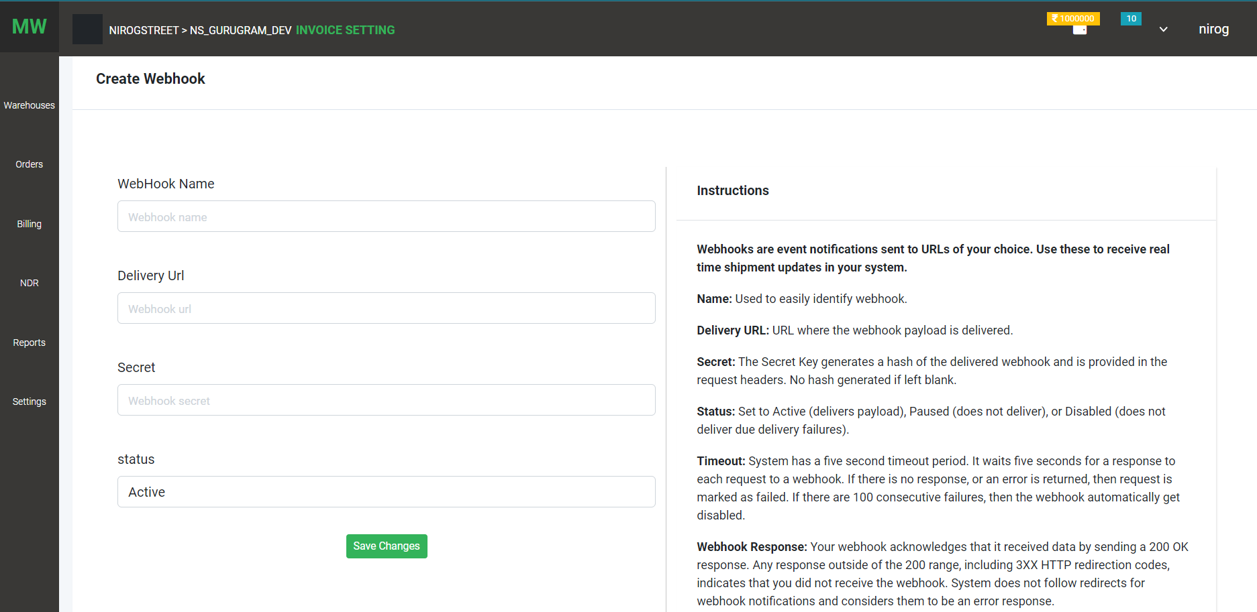

1. 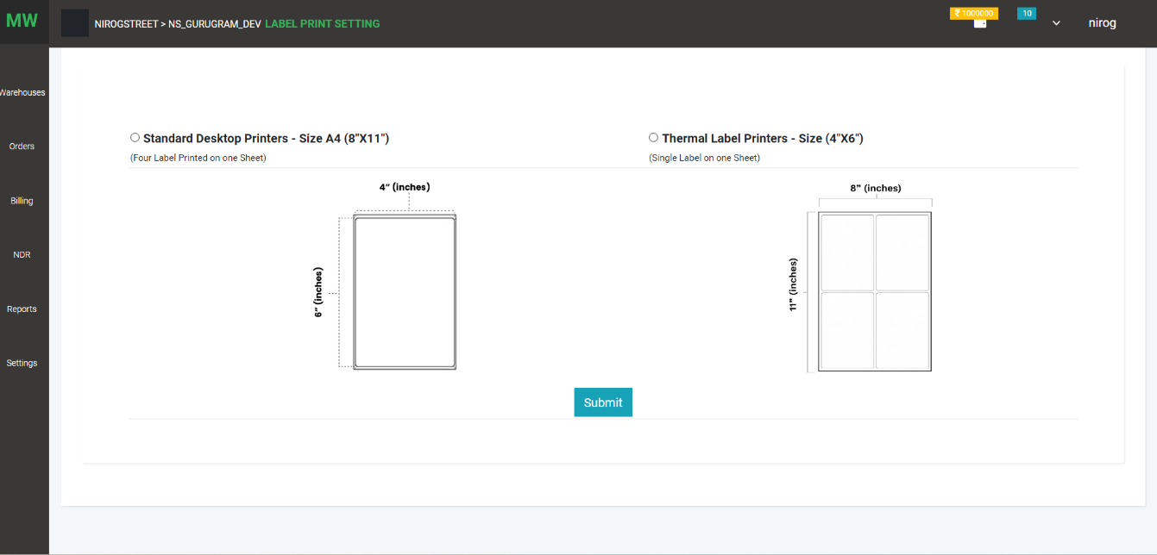Label setting: Use can set label print
2. 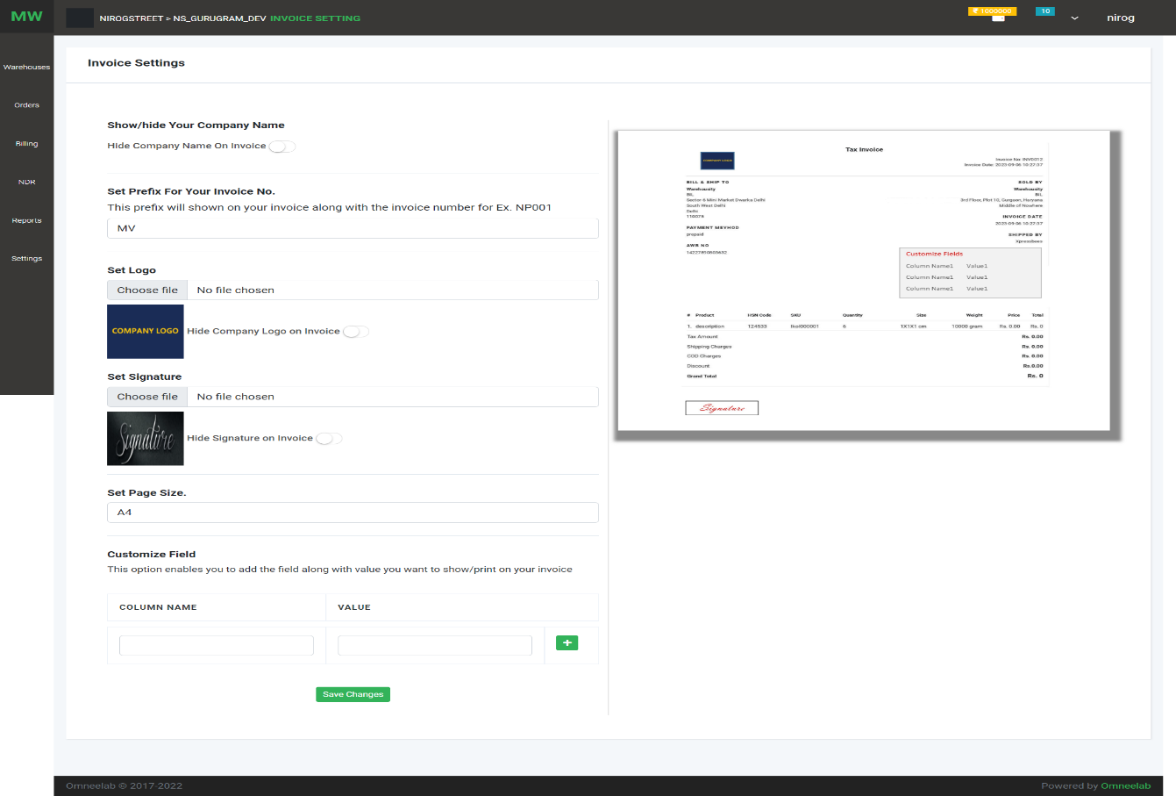Invoice Setting :

On this page, the user can manage invoice settings like show/hide the company name, logo, signature, and add custom field. These changes are shown on the invoice

1. KYC:

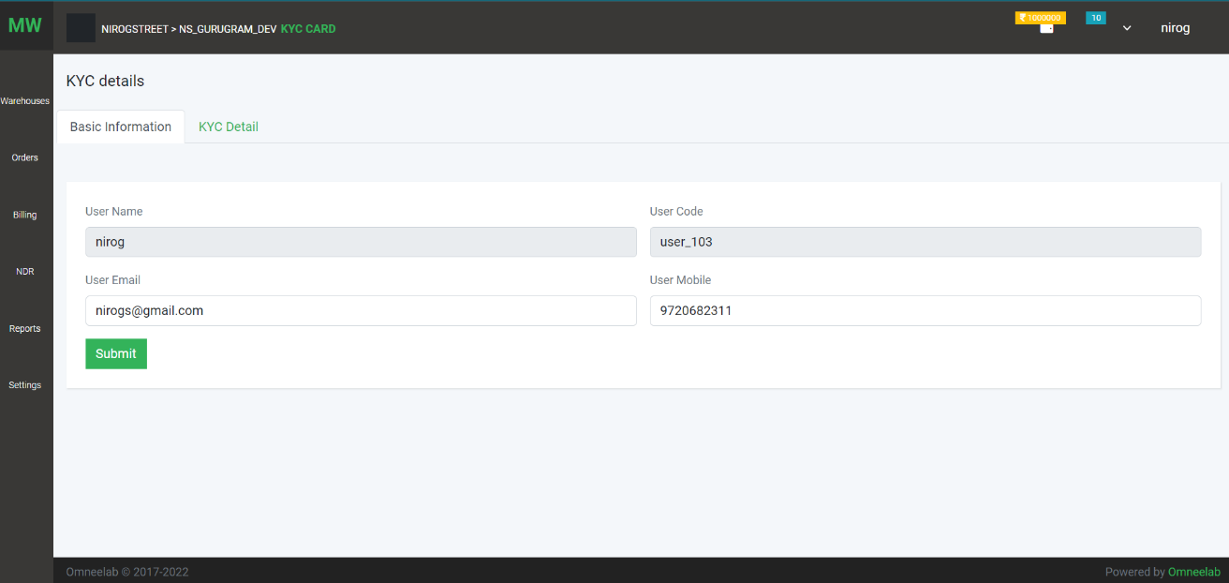On this page, users can client basic information like email phone

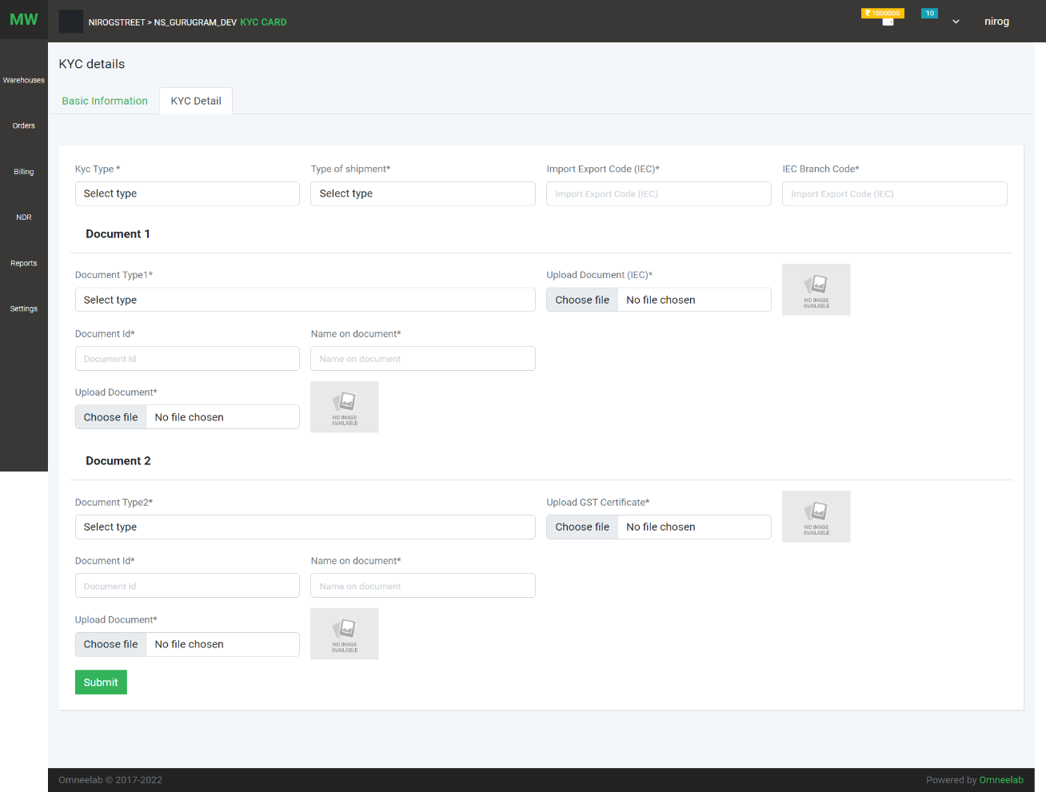 On this page user can add or update the KYC detail of the client

1. WMS: User can add and configure WMS, ERPs, and Unicommerce

List

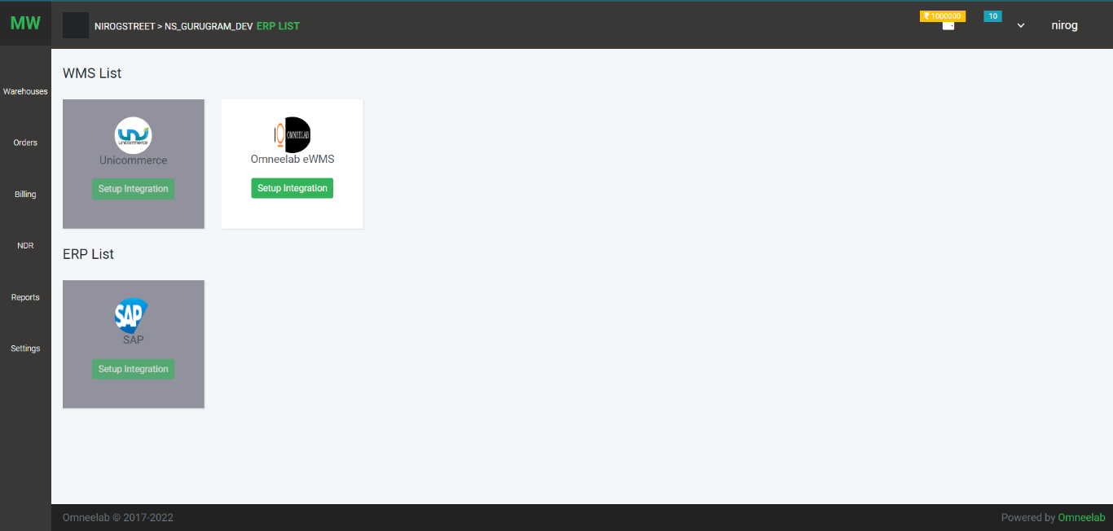

Configuration screen

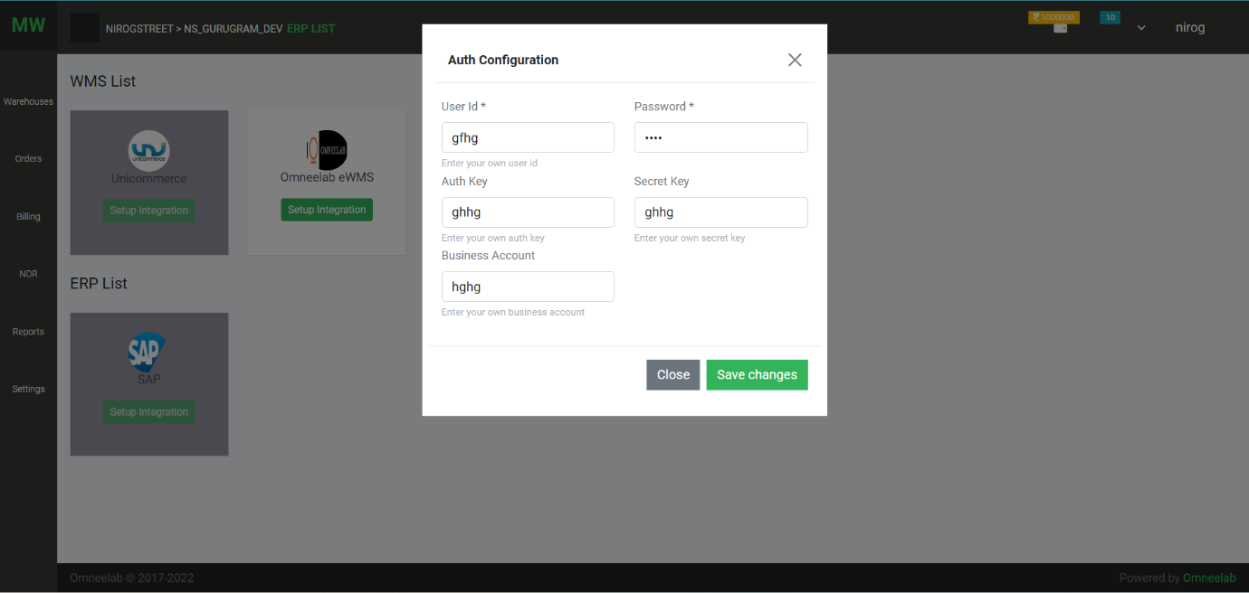

1. Rate Card:

Rate contract

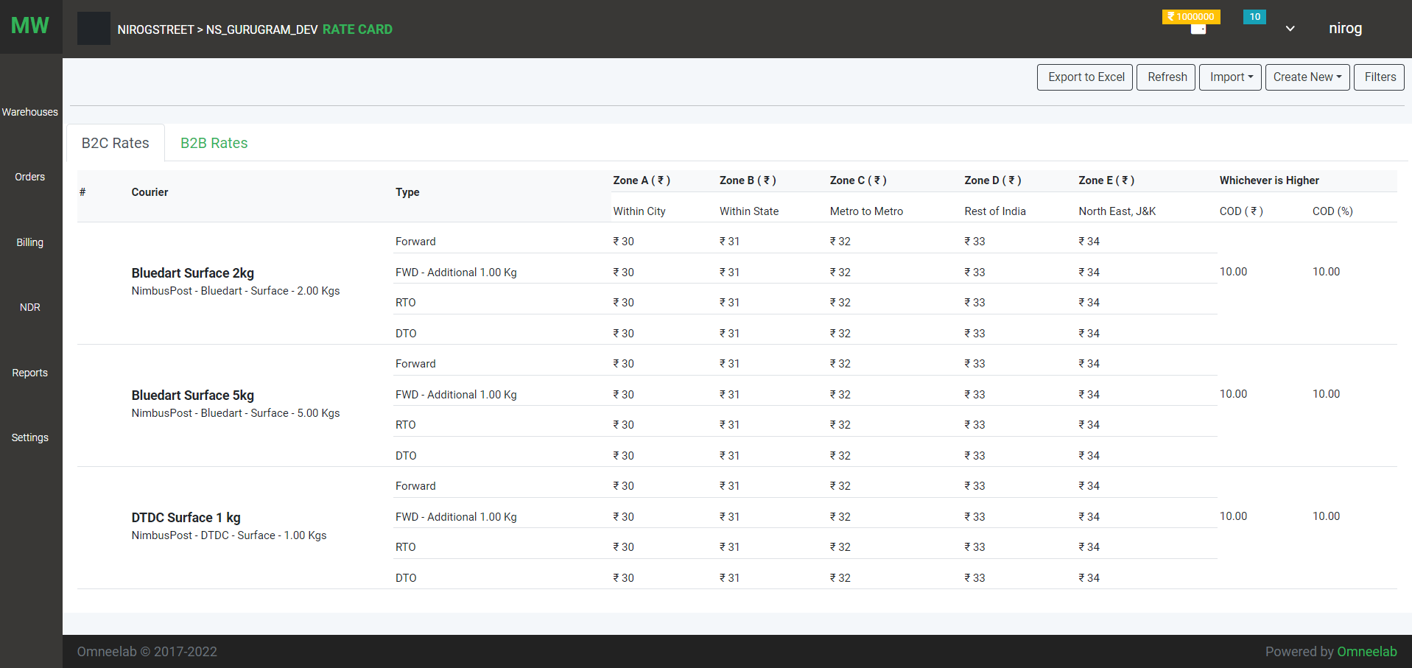

Add Rate Contract Manually

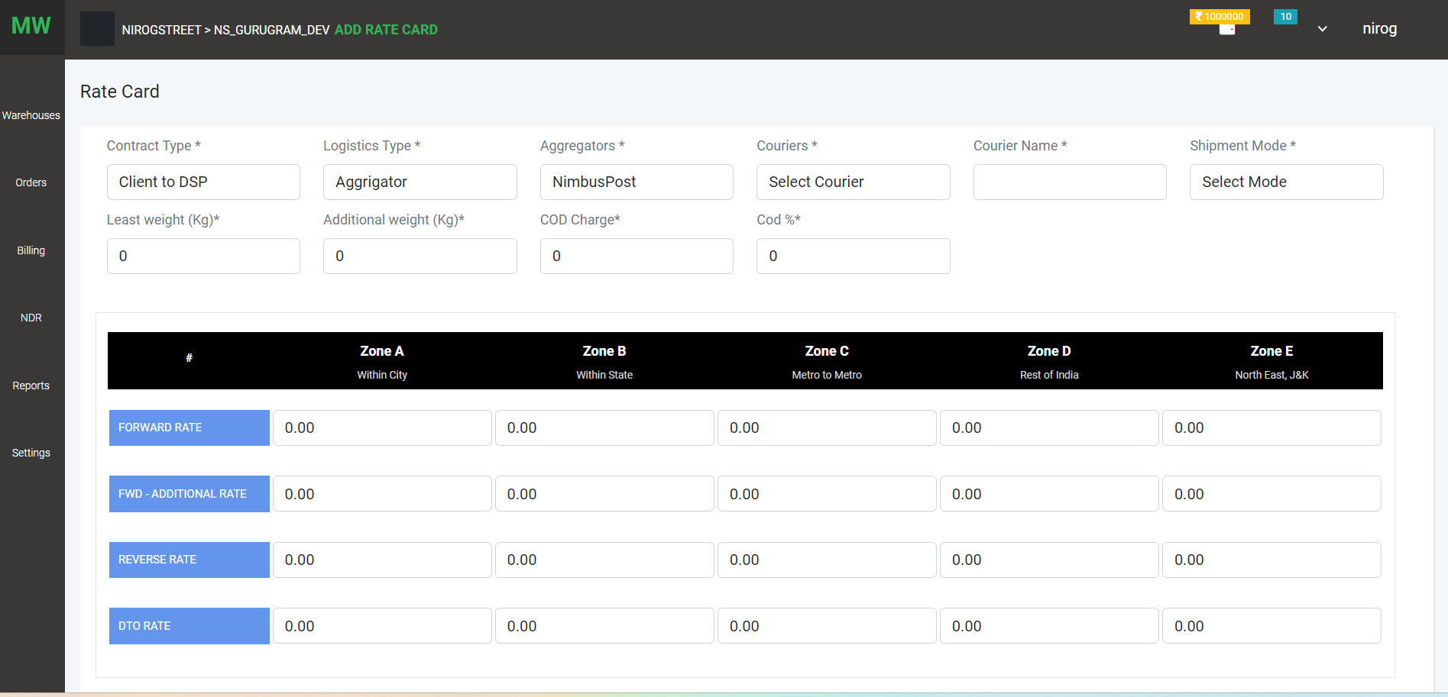

Import option for upload Rate Contract

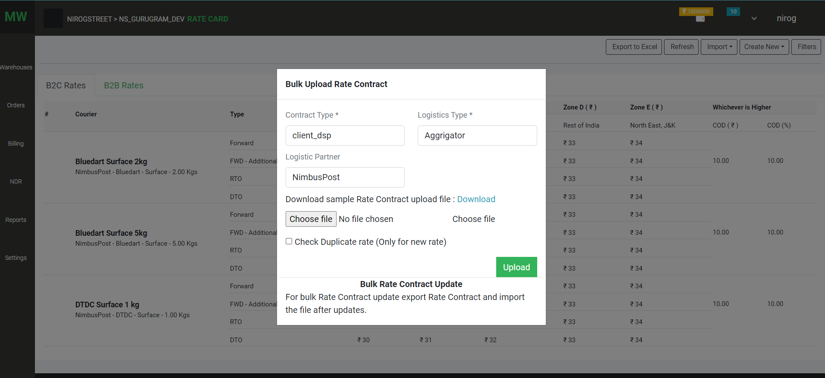

1. Zone: list of zones

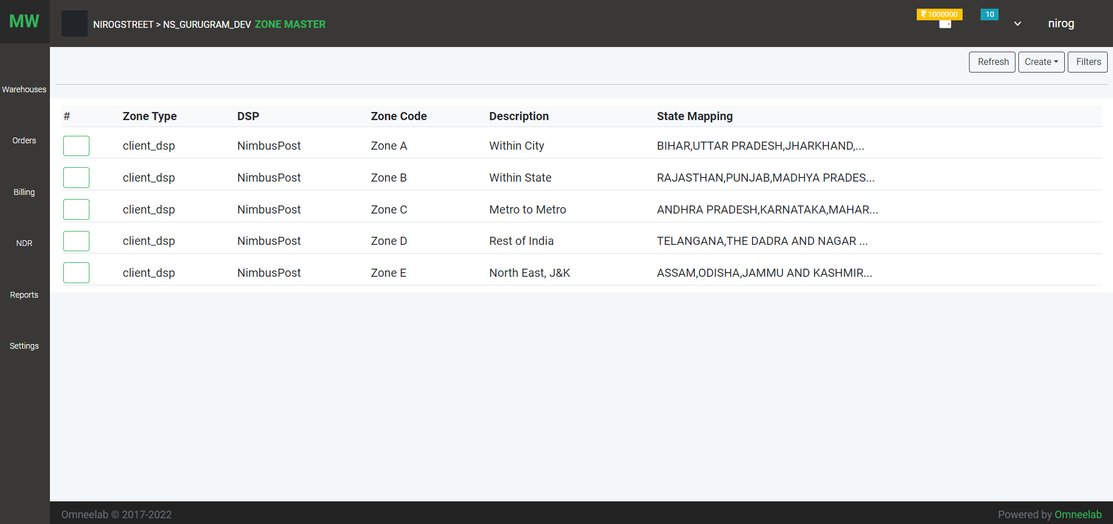

Zone creation

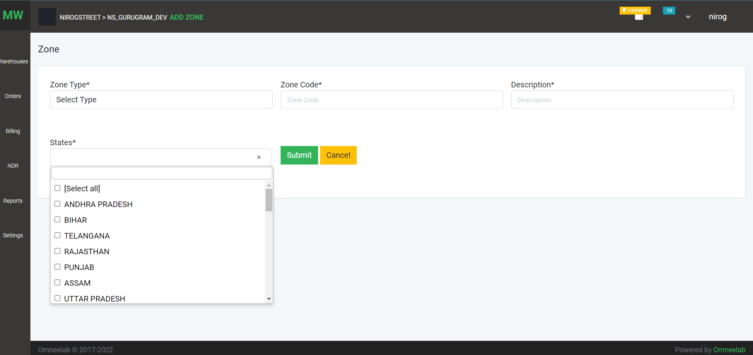

1. Pincode :

List of pincodes

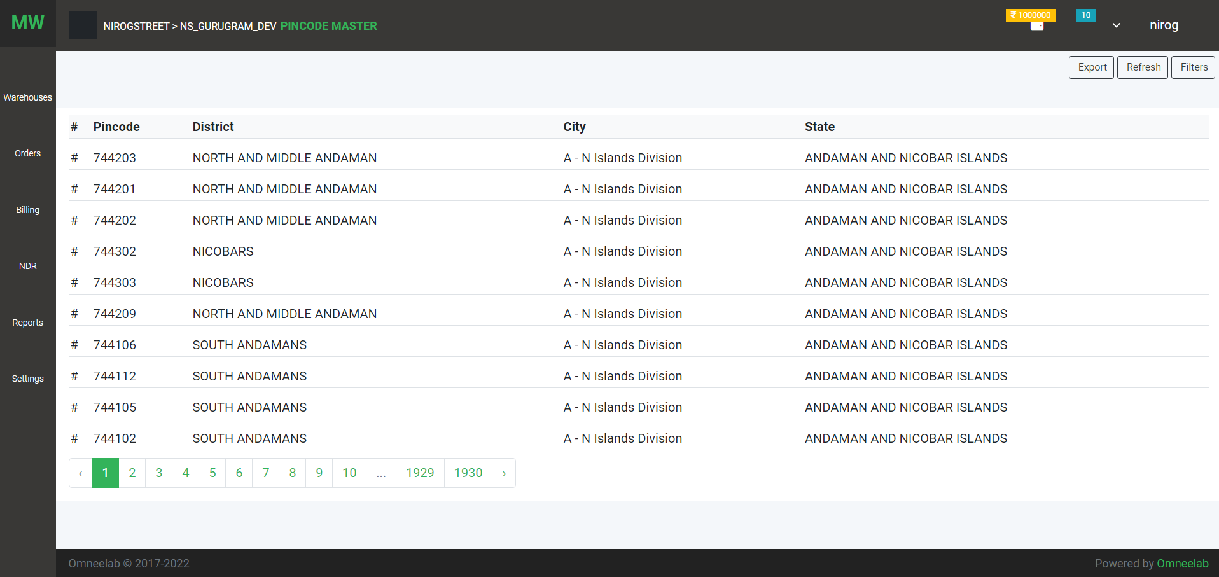

1. Rate Calculator: User can see rate contract and calculate total rate of shipment on particular distance (pick location, destination)

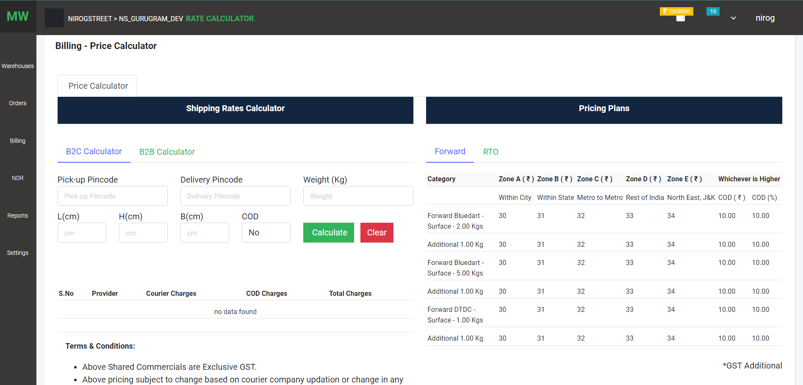

1. Rule Allocation:

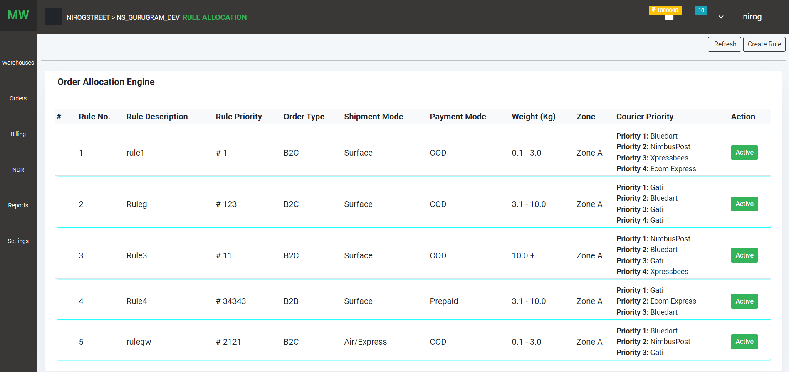Rule list

Orders come from outside like WMS and channel partners then orders are pushed to the logistics partner according to rules defined by the client

Rule creation

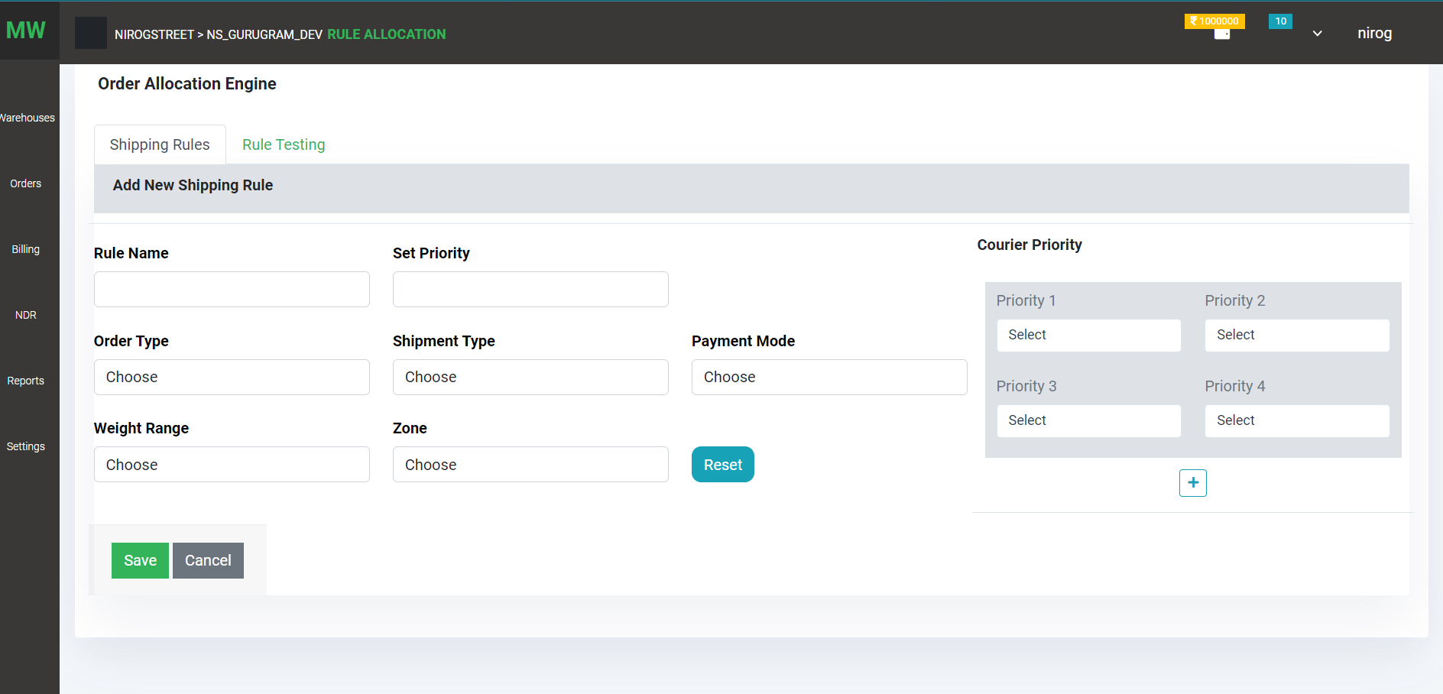

Order rules are created according to the above fields like order type, payment mode, shipment type, weight range and zone (zones are defined by pin codes).

Courier partners that are integrated with clients are selected with priority